**(1) What are the advantages of Bootstrap?**

**A.** Saving time and effort by providing ready-made components and style that can be customized and combined.

● Easy to use

● Responsive features

●Consistent Design

●Mobile-first approach

●Browser compatibility

**(2) What is a Bootstrap Container, and how does it work?**

**A.** Bootstrap Container is used to set the content’s margins dealing with the responsive behaviours of your layout. It contains the row elements and the row elements are the containers of column (known as grid system). The containers class is used to create boxed content.

**There are three types of container classes available in bootstrap.**

**→** Default-Container (container)

**→** Responsive-Container (along with sm, md, lg, xl, xxl)

**→** Fluid-Container (container-fluid)

**(1) Default-Container**

The default container uses ‘.container’ class. It provides a responsive fixed-width container.

**Input:**

<!DOCTYPE html>

<html lang="en">

<head>

    <meta charset="UTF-8">

    <meta name="viewport" content="width=device-width, initial-scale=1.0">

    <title>Document</title>

    <link href="https://cdn.jsdelivr.net/npm/bootstrap@5.0.2/dist/css/bootstrap.min.css" rel="stylesheet" integrity="sha384-EVSTQN3/azprG1Anm3QDgpJLIm9Nao0Yz1ztcQTwFspd3yD65VohhpuuCOmLASjC" crossorigin="anonymous">

    <script src="https://cdn.jsdelivr.net/npm/bootstrap@5.0.2/dist/js/bootstrap.bundle.min.js" integrity="sha384-MrcW6ZMFYlzcLA8Nl+NtUVF0sA7MsXsP1UyJoMp4YLEuNSfAP+JcXn/tWtIaxVXM" crossorigin="anonymous"></script>

</head>

<body>

    <div class="container" style="background-color: aqua; color: black;">

        <h1>Default container</h1>

    </div>

</body>

</html>

**Output:**



**(2) Responsive-container**

Responsive containers allow you to specify a class that is wide until the specified breakpoint is reached, after which we apply max-widths for each of the higher breakpoints.

**Input:**

<!DOCTYPE html>

<html lang="en">

<head>

    <meta charset="UTF-8">

    <meta name="viewport" content="width=device-width, initial-scale=1.0">

    <title>Document</title>

    <link href="https://cdn.jsdelivr.net/npm/bootstrap@5.0.2/dist/css/bootstrap.min.css" rel="stylesheet" integrity="sha384-EVSTQN3/azprG1Anm3QDgpJLIm9Nao0Yz1ztcQTwFspd3yD65VohhpuuCOmLASjC" crossorigin="anonymous">

    <script src="https://cdn.jsdelivr.net/npm/bootstrap@5.0.2/dist/js/bootstrap.bundle.min.js" integrity="sha384-MrcW6ZMFYlzcLA8Nl+NtUVF0sA7MsXsP1UyJoMp4YLEuNSfAP+JcXn/tWtIaxVXM" crossorigin="anonymous"></script>

</head>

<body>

    <div class="container-lg" style="background-color: aqua; color: black;">

        <h1>Responsive container</h1>

    </div>

</body>

</html>

**Output:**



**(3) fluid-container**

Fluid-container uses the ‘.container-fluid’ class. It is used for a full-width container, spamming the entire width of the viewport.

**Input:**

<!DOCTYPE html>

<html lang="en">

<head>

    <meta charset="UTF-8">

    <meta name="viewport" content="width=device-width, initial-scale=1.0">

    <title>Document</title>

    <link href="https://cdn.jsdelivr.net/npm/bootstrap@5.0.2/dist/css/bootstrap.min.css" rel="stylesheet" integrity="sha384-EVSTQN3/azprG1Anm3QDgpJLIm9Nao0Yz1ztcQTwFspd3yD65VohhpuuCOmLASjC" crossorigin="anonymous">

    <script src="https://cdn.jsdelivr.net/npm/bootstrap@5.0.2/dist/js/bootstrap.bundle.min.js" integrity="sha384-MrcW6ZMFYlzcLA8Nl+NtUVF0sA7MsXsP1UyJoMp4YLEuNSfAP+JcXn/tWtIaxVXM" crossorigin="anonymous"></script>

</head>

<body>

    <div class="container-fluid" style="background-color: aqua; color: black;">

        <h1>Fluid container</h1>

        <p>Hallo</p>

    </div>

</body>

</html>

**Output:**



**(3) What are the default Bootstrap text settings?**

**A.** Bootstrap 5 uses a default font-size of 1rem (16px by default), and its line-height is 1.5.

**Input:**

<!DOCTYPE html>

<html lang="en">

<head>

    <meta charset="UTF-8">

    <meta name="viewport" content="width=device-width, initial-scale=1.0">

    <title>Document</title>

    <link href="https://cdn.jsdelivr.net/npm/bootstrap@5.0.2/dist/css/bootstrap.min.css" rel="stylesheet" integrity="sha384-EVSTQN3/azprG1Anm3QDgpJLIm9Nao0Yz1ztcQTwFspd3yD65VohhpuuCOmLASjC" crossorigin="anonymous">

    <script src="https://cdn.jsdelivr.net/npm/bootstrap@5.0.2/dist/js/bootstrap.bundle.min.js" integrity="sha384-MrcW6ZMFYlzcLA8Nl+NtUVF0sA7MsXsP1UyJoMp4YLEuNSfAP+JcXn/tWtIaxVXM" crossorigin="anonymous"></script>

</head>

<body>

    <div class="container mt-3">

       <p class="h1">h1 Hii</p>

       <p class="h2">h2 Hii</p>

       <p class="h3">h3 Hii</p>

       <p class="h4">h4 Hii</p>

       <p class="h5">h5 Hii</p>

       <p class="h6">h6 Hii</p>

    </div>

</body>

</html>

**Output:**

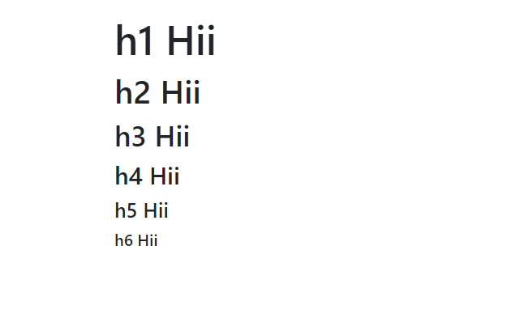

**(4) What do you know about the Bootstrap Grid System?**

**A.** Bootstrap’s grid system uses a series of containers, rows, and column to layout and align content. It’s built with flexbox and is fully responsive.

Bootstrap’s grid system allows up to 12 columns across the page.

**Example:**

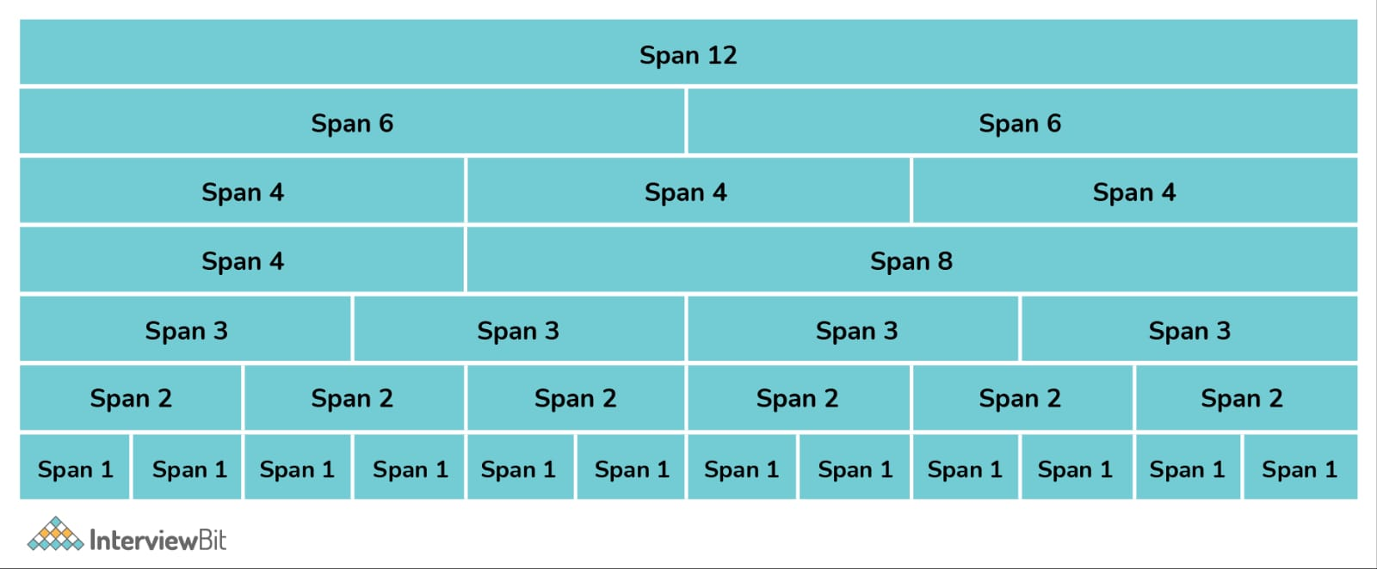

● xs (screens less than 768px wide)

● sm (screens equal to or greater than 768px wide)

● md (screens equal or greater than 992px wide)

● lg (screens equal to or greater than 1200px wide)

**Input:**

<!DOCTYPE html>

<html lang="en">

<head>

    <meta charset="UTF-8">

    <meta name="viewport" content="width=device-width, initial-scale=1.0">

    <title>Document</title>

    <link href="https://cdn.jsdelivr.net/npm/bootstrap@5.0.2/dist/css/bootstrap.min.css" rel="stylesheet" integrity="sha384-EVSTQN3/azprG1Anm3QDgpJLIm9Nao0Yz1ztcQTwFspd3yD65VohhpuuCOmLASjC" crossorigin="anonymous">

    <script src="https://cdn.jsdelivr.net/npm/bootstrap@5.0.2/dist/js/bootstrap.bundle.min.js" integrity="sha384-MrcW6ZMFYlzcLA8Nl+NtUVF0sA7MsXsP1UyJoMp4YLEuNSfAP+JcXn/tWtIaxVXM" crossorigin="anonymous"></script>

</head>

<body>

    <div class="row bg-primary mt-4">

        <div class="col-sm-4 bg-info">sm-4</div>

        <div class="col-sm-4 bg-warning">sm-4</div>

        <div class="col-sm-4 bg-info">sm-4</div>

    </div>

    <div class="row bg-success mt-4">

        <div class="col-md-4 bg-warning">sm-4</div>

        <div class="col-md-8 bg-info">sm-8</div>

    </div>

</body>

</html>

**Output:**

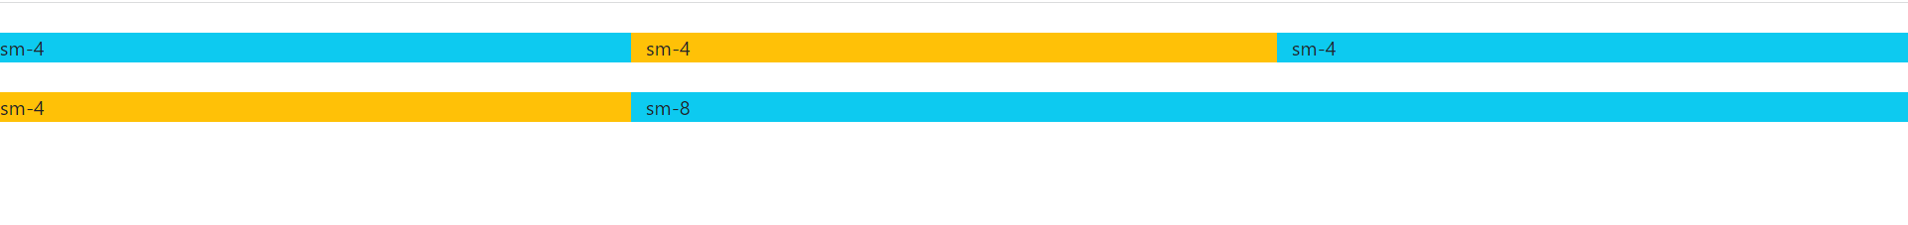

**(5) What is the difference between Bootstrap 4 and Bootstrap 5**

**A.**

|  |  |  |
| --- | --- | --- |
| **Basis of** | **Bootstrap 4** | **Bootstrap 5** |
| *Grid system* | It has 5 tier | It has 6 tier |
| *Color* | It has limited colors | Extra colors added |
| *jQuery* | It has jQuery and all related plugins | jQuery is removed |
| *Internet Explore* | Supports both IE 10 and 11 | Doesn’t Support IE 10 and 11 |
| *Form Elements* | Form uses whatever default browser provide | Form can be customized and form controls can be added, they would not depend on browser |
| *Utility API* | We cannot modify utilities | Modify and also create our own utilities |
| *Gutter* | Use gutter with font size in px | Use .g* with font size in rem |
| *Vertical classes* | Columns can be positioned  relative | Columns cannot be positioned relative |
| *icon* | Doesn’t have its own SVG icons | its own SVG icons |
| *jumbotron* | It’s supported | Doesn’t support |
| *Card deck* | Card deck card used to create a set of card with equal width and height | Card deck class remove |
| *navbar* | We have inline-block property and we will get white dropdown | Inline-block property is removed and we will get black dropdown |
| *Static site generator* | Uses Jekyll software | Uses Hugo software |
| *Flexbox grid* | Easier to implement vertical designs, and the columns and row can be easily be implemented | Advanced grid system is made available. |
| *RTL (Right to Left) supports* | It does not enable RTL | It enables RTL |
| *Off canvas* | It does not support off canvas | It support off canvas |

**(6) What is a Button Group, and what is the class for a basic Button Group?**

**A.** Button groups is a class of name “btn-group” which is used to create a series of buttons in groups vertically or horizontally.

**Input:**

<!DOCTYPE html>

<html lang="en">

<head>

    <meta charset="UTF-8">

    <meta name="viewport" content="width=device-width, initial-scale=1.0">

    <title>Document</title>

    <link href="https://cdn.jsdelivr.net/npm/bootstrap@5.0.2/dist/css/bootstrap.min.css" rel="stylesheet" integrity="sha384-EVSTQN3/azprG1Anm3QDgpJLIm9Nao0Yz1ztcQTwFspd3yD65VohhpuuCOmLASjC" crossorigin="anonymous">

    <script src="https://cdn.jsdelivr.net/npm/bootstrap@5.0.2/dist/js/bootstrap.bundle.min.js" integrity="sha384-MrcW6ZMFYlzcLA8Nl+NtUVF0sA7MsXsP1UyJoMp4YLEuNSfAP+JcXn/tWtIaxVXM" crossorigin="anonymous"></script>

</head>

<body>

    <div class="btn-group">

        <button type="button" class="btn btn-danger">RESET</button>

        <button type="button" class="btn btn-success">SUBMIT</button>

        <button type="button" class="btn btn-warning">CANCLE</button>

    </div>

</body>

</html>

**Output:**

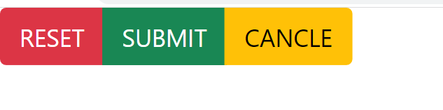

**(7) How can you use Bootstrap to make thumbnails?**

**A.**

**Step 1:** Include Bootstrap and jQuery CDN into the <head> tag before all other stylesheets to load our CSS.

**Step 2:** Add <div> tag in the HTML body with class row. In that <div> create four *div* sections to create four images.

**Step 3:** Add “col-sm-6” and “col-md-3” to four *div* sections which creates webpage responsive.

**Step 4:** Add <a> tag with class value thumbnail to define the link of the image in the next line.

**Input:**

<!DOCTYPE html>

<html lang="en">

  <head>

    <title></title>

    <link rel="stylesheet" href="http://maxcdn.bootstrapcdn.com/bootstrap/3.3.6/css/bootstrap.min.css"/>

    <script src="https://ajax.googleapis.com/ajax/libs/jquery/1.12.0/jquery.min.js"></script>

    <script src="http://maxcdn.bootstrapcdn.com/bootstrap/3.3.6/js/bootstrap.min.js"></script>

  </head>

  <body>

    <h3 style="color: green">Bootstrap thumbnails</h3>

    <div class="row">

      <div class="col-sm-6 col-md-3">

        <a href="#" class="thumbnail">

          <img src="C:\Users\makavana tushar\Downloads\aroni-arsa-children-little.jpg" style="height: 200px; width: 200px">

        </a>

      </div>

      <div class="col-sm-6 col-md-3">

        <a href="#" class="thumbnail">

          <img src="C:\Users\makavana tushar\Downloads\flower.jpg" style="height: 200px; width: 200px">

        </a>

      </div>

      <div class="col-sm-6 col-md-3">

        <a href="#" class="thumbnail">

          <img src="C:\Users\makavana tushar\Downloads\Girls_Photo_shoot_Pune_T_003.jpg" style="height: 200px; width: 200px">

        </a>

      </div>

      <div class="col-sm-6 col-md-3">

        <a href="#" class="thumbnail">

          <img src="C:\Users\makavana tushar\Downloads\KOA_Nassau_2697x1517.jpg" style="height: 200px; width: 200px">

        </a>

      </div>

    </div>

</body>

</html>

**Output:**

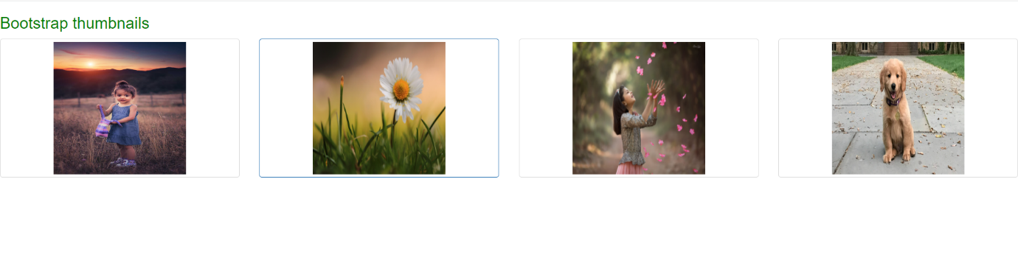

**(8) In Bootstrap 4, what is flexbox?**

**A.** Bootstrap 4 now uses flexbox, instead of floats, to handle the layout. The flexible box layout module, makes it easier to design flexible responsive layout structure without using float or positioning.

**Input:**

<!DOCTYPE html>

<html lang="en">

  <head>

    <title></title>

    <link rel="stylesheet" href="https://cdn.jsdelivr.net/npm/bootstrap@4.6.2/dist/css/bootstrap.min.css">

    <script src="https://cdn.jsdelivr.net/npm/jquery@3.6.4/dist/jquery.slim.min.js"></script>

    <script src="https://cdn.jsdelivr.net/npm/popper.js@1.16.1/dist/umd/popper.min.js"></script>

    <script src="https://cdn.jsdelivr.net/npm/bootstrap@4.6.2/dist/js/bootstrap.bundle.min.js"></script>

  </head>

  <body>

    <div class="container mt-5">

        <div class="d-flex justify-content-around bg-secondary text-white">

            <div class="p-3 bg-danger">flex-1</div>

            <div class="p-3 bg-info">flex-2</div>

            <div class="p-3 bg-success">flex-3</div>

        </div>

    </div>

</body>

</html>

**Output:**



**(9) How can one create an alert in Bootstrap?**

**A.**  Bootstrap alerts are used to provide to create predefined alert messages.

**Input:**

<!DOCTYPE html>

<html lang="en">

  <head>

    <title></title>

    <link href="https://cdn.jsdelivr.net/npm/bootstrap@5.3.1/dist/css/bootstrap.min.css" rel="stylesheet">

  <script src="https://cdn.jsdelivr.net/npm/bootstrap@5.3.1/dist/js/bootstrap.bundle.min.js"></script>

</head>

  </head>

  <body>

    <div class="container">

        <div class="alert alert-warning"><strong>warning!</strong> let's play cricket</div>

        <div class="alert alert-info"><strong>info!</strong> let's play cricket</div>

        <div class="alert alert-success"><strong>success!</strong> let's play cricket</div>

    </div>

</body>

</html>

**Output:**

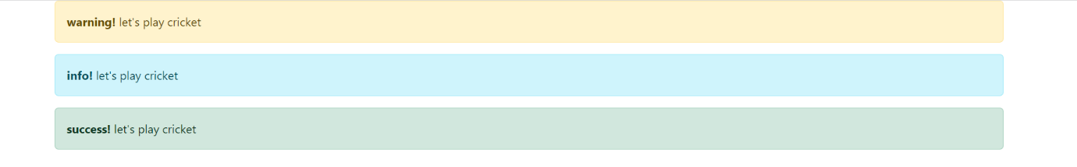

**(10) What is a bootstrap card and how would you create one?**

**A.** A card is a flexible and extensible content container. It includes options for headers and footers, a wide variety of content, contextual background colors, and powerful display options.

**Input:**

<!DOCTYPE html>

<html lang="en">

<head>

    <title>Bootstrap Card</title>

    <meta charset="utf-8">

    <meta name="viewport" content="width=device-width, initial-scale=1">

    <link rel="stylesheet" href="https://maxcdn.bootstrapcdn.com/bootstrap/4.3.1/css/bootstrap.min.css">

</head>

<body>

    <div class="container">

        <h1 class="text-primary text-center">Bootstrap card</h1>

        <div class="card">

            <div class="card-header bg-info">Header</div>

            <div class="card-body bg-warning">Content</div>

            <div class="card-footer bg-success">Footer</div>

        </div>

    </div>

</body>

</html>

**Output:**

